SUMMARY

What problem, using what methods and with what results was solved. It must be written so that it can be understood not just by a specialist in the given field, but by any person acquainted with the subject of the thesis. It must not include abbreviations, with the exception of commonly used ones. The Czech and English summaries combined should not be longer than 1 page (for bachelor and master theses).

ACKNOWLeDGEMENT

We would like to thank xxxxxx and the Department of xxxxx, UCT Prague, for providing xxxxx.

TABLE OF CONTENTS

1 INTRODUCTION 1

1.1 General instructions 1

1.1.1 Page setup 1

1.1.2 Style and font size 3

1.1.3 Numbering of chapters, subchapters and sections 3

1.1.4 Citations and references 4

1.2 Brief instructions on how to write scientific texts 6

1.2.1 Quantities and units 7

1.2.2 Tables 7

1.2.3 Figures and graphs 12

1.2.4 Equations and formulas 13

2 State of Art 15

3 EXPERIMENTAL PART 16

4 RESULTS AND DISCUSSION 17

5 CONCLUSIONS 18

REFERENCES 19

LIST OF ABBREVIATIONS 20

LIST OF SYMBOLS 21

LIST OF TABLES 22

LIST OF FIGURES 23

APPENDICES 24

# INTRODUCTION

Brief, clear and concise introduction into the problem with a clearly defined reasons and aims of the bachelor/master/etc. task.

## General instructions

This document describes and illustrates the main general principles; however, different departments can provide more detailed or slightly modified instructions (usually affected by what is customary in the field). Therefore, it is advisable to discuss all rules with the supervisor in advance. A technical note: This template might not work in LibreOffice.

### Page setup

All margins must be set at 25 mm. Bachelor and master theses are typically printed single sided (the text is on the right page); however, also in case of duplex printing the margins are wide enough (if the left and the right margins were set differently, in case of duplex printing the margins for odd page would have to be set differently from the margins for even page).

A brief summary of the setup is given in **Tab. 1.1**, the recommended length of the thesis and its parts is shown in **Tab. 1.2 and Tab. 1.3**.

**Table 1.1**: The basic page setup for bachelor theses, master theses and dissertations. For table and figure captions, use the “Figure and Table Caption” style. For the text in the table, use the “Text in Table” style

|  |  |  |  |
| --- | --- | --- | --- |
|  | **Bachelor thesis** | **Master thesis** | **Dissertation** |
| Margin size | 25 mm | 25 mm | 35 mm |
| Format of page (setup in editor) | A4 | A4 | A4 |
| Format of page for printing | A4 | A4 | A4 / B5* |

* The workers in the print shop will resize the format from A4 to B5. For preview/check, adjust the print size to ca 80%.

**Table 1.2**: Recommended length – number of pages of Bachelor thesis (BT)

|  |  |  |  |  |
| --- | --- | --- | --- | --- |
|  | **Bachelor thesis** | | | |
|  | **FCT** | **FET** | **FFBT** | **FCE** |
| Summary in Czech and English (total) | 1 | 1 | 1 | 1 |
| Introduction | 1–2 | 1–2 | 1–2 | Length of BT in accordance with what is usual in the field and as agreed with supervisor |
| Literary review | Length of BT in accordance with what is typical in the field and as agreed upon with supervisor | Length of BT in accordance with what is usual in the field and as agreed with supervisor | 1-5 |
| Total length  of thesis | 30** | 30* | 30** |

* Numbered pages without appendices

** Recommended maximum length includes any figures and tables. No penalties for exceeding the recommended length.

**School of Business:** The appropriate length of the theoretical part must be discussed with the supervisor. Bachelor theses are primarily focused on practical implementations. Critical literature search is the basis for the theoretical part of the BT as an essential starting point for the practical application of the selected method.

**Table 1.3**: Recommended length – number of pages of Master thesis (MT)

|  |  |  |
| --- | --- | --- |
|  | **Master thesis** | **Dissertation** |
| Summary in Czech and English (total) | 1 | As agreed upon by student and supervisor |
| Introduction | 1–2 |
| Literary review | 15–25 |
| Total length of thesis | Length of MT in accordance with what is typical in the field and as agreed upon with supervisor |

Pages are numbered using Arabic numerals, centred at the bottom of the page; pages are counted and numbered starting with the first page following the last page of the table of contents (page no. 1).

### Style and font size

The basic recommended font size is 12 pt (points). Use a serif font (e.g., Times New Roman). This font size is recommended for all types of theses, except for A4 dissertations, for which a font size of 11 pt is recommended. Use 1.5 line spacing, justify text, paragraphs are aligned to a block and the space between them is set to 10 pt. Use the “Normal” style. Use predefined styles provided in **Tab. 1.4**.

In case you decide to change the size of the basic font used in the text (e.g., to 11 pt), you need to adjust the font size for tables and figures styles.

### Numbering of chapters, subchapters and sections

Chapters shall always begin on a new page (on the right, in case of duplex printing), in decimal classification they have single-figure number, their title is in bold. Titles of subchapters at lower levels are in lower case with the first letter capitalized.

Numbers of chapters at all levels are written without dots after the last numeral.

In addition to numbered chapters that will be included in the Table of Contents, also titles without numbers can be added; the format is normal font in italics, using the Heading 4 style.

If the thesis does not include own experimental results, it may have fewer main chapters, e.g., the chapter on Experimental Part will not be included.

**Table 1.4**: Most important predefined styles

|  |  |  |  |
| --- | --- | --- | --- |
| **Name of style** | **What is it used for** | **How to reference in text** | **Note** |
| Normal | Plain text |  | 12 pt for bachelor theses, diploma theses and dissertations in B5 format / 11 pt for dissertations in A4 format |
| Heading 1 | Titles of chapters | see Chpt. 1 |  |
| Heading 1 unnumbered | Titles “List …” |  |  |
| Heading 2 | Titles of sections | see Sect. 1.1 |  |
| Heading 3 | Titles of paragraphs | See Para. 1.1.1 |  |
| Heading 4 | Division with a paragraph |  | not included in the Table of Contents |
| Captions for figures and tables | Captions for figures and tables | see **Fig. 1**, see **Tab. 1** | 11 pt |
| Texts in tables | Texts in tables |  | 11 pt, left justify (adjust alignment by hand, if necessary), single line spacing |
| Equations | Equations on a separate line | see eq. (1.1) | set two tabulators, one for the equation, the other for the number |
| List of symbols | List of symbols |  | same as Normal, but line spacing 1 without separation of paragraphs |

### Citations and references

One of the styles below is recommended for in-text citations and the list of references:

* The ACS style. Citations are numbered using Arabic numerals in the order they appear in the text, including numbers and schemes. It is advisable to use numbers in square brackets (e.g., [1]), and not as upper indices (like this1) – in this way you will avoid confusing exponentiation with in-text citations.
* The Harvard system/style (author + year of publication). References are ordered in the list of references alphabetically by the first name/word, on the second level by the year of publication.

The in-text citation is part of the sentence; if it is at the end of the sentence, the full stop is placed after the citation.

#### Abbreviations of journals

Names of journals in the reference list are either all abbreviated (in order to check the abbreviations, use the Chemical Abstracts Service Source Index (CASSI) – see below), or full names are used; do not combine the two styles! In order to check an abbreviation, use one of the following:

* CASSI
  + either online (<http://cassi.cas.org>),
  + or the list of CASSI abbreviations for 1000+ most frequently cited journals in appendix 14-1, pp 328-339, in Janet, S. D.; Leah, S.; Paula, M. B., References. In The ACS Style Guide, American Chemical Society: 2006; pp 287-341. <http://dx.doi.org/10.1021/bk-2006-STYG.ch014>,
* or import the list of abbreviations used in the Collection of Czechoslovak Chemical Communications (courtesy of Dr. Valter) to EndNote. You will find the list for download and instructions for import at <https://www.chemtk.cz/cs/82942-endnote>.

Do not join more citations under one number (i.e., 1a, 1b, etc.). In EndNote, you have to disable “Edit / Output Styles / Edit Style / Citations / Numbering / Use one number for references cited together” for the ACS style, see **Fig. 1.1**.

You can also use the Czech Standard CSN 010197 or any other commonly used style, but you always have to use it consistently throughout the thesis and following an agreement with the supervisor.

Use reference managers (EndNote, Mendeley, etc.) to the fullest extent possible, but do not forget that it is your responsibility to check the correctness of the generated citations (check whether the used style, abbreviations, names of authors, etc. are up to date).

Recommended sources:

* Guidelines of the UCT Press for citations in the ACS or ISO (in Czech) at <http://vydavatelstvi.vscht.cz/apps/uid_ea-002/>.
* The chapter on References in the ACS Style Guide (in English) <http://pubs.acs.org/doi/abs/10.1021/bk-2006-STYG.ch014>.
* Chemical Abstracts Service Source Index <http://cassi.cas.org/>.

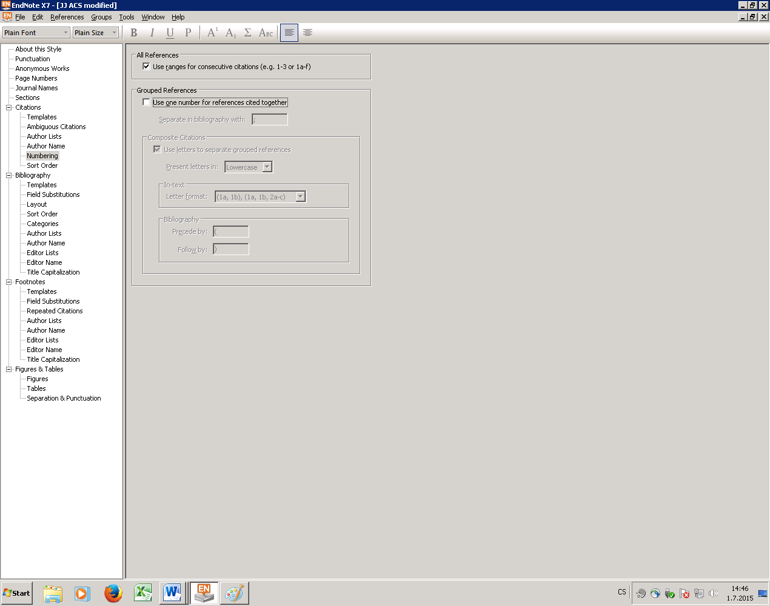

**Fig. 1.1**: Disabling joint citations in EndNote for the ACS style

*Recommended way of referencing used AI tools*

Prompt. Name of AI tool. Version of AI tool (date of release). Name of company that created the AI tool. Creation date of work/content. URL address of AI tool or unique URL of work/content – extent and purpose of use of tool.

The format is to be adapted to the citation style used.

## Brief instructions on how to write scientific texts

When writing scientific mathematical or chemical texts, use consistent terminology, chemical nomenclature, the SI system of units and comply with the rules for scientific publishing. For more, see:

* Coghill, A. M.; Garson, L. R.; American Chemical Society, *The ACS style guide: effective communication of scientific information*. 3rd ed.; Amer. Chemical Soc.: Washington, 2006; p xiv, 430, 978-0-8412-3999-9. <http://pubs.acs.org/isbn/9780841239999>.  
  NB: Czech and English scientific writing are slightly different (e.g., space between the number and the per cent sign).

### Quantities and units

For quantities, we use letters of the Latin or Greek alphabet in line with the relevant recommendations. Symbols for physical quantities are in italics.

Names of units always have a lowercase first letter (meter, kilogram, kelvin, ampere). Symbols are always written upright. A space is always used to separate the unit from the number. Compound units are recommended to be used with a space, with negative exponents, e.g., Pa s, $\text{J }{\text{K}}^{\text{-1}}\text{ k}{\text{g}}^{\text{-1}}$.

The basic rule for writing quantities and units is CONSISTENCY throughout the thesis and respecting professional recommendations.

### Tables

Figures and tables can be numbered continuously (in the order as they appear in the document); however, we advise you to number them using the number of the chapter and the serial number of the table or figure in the given chapter (in case you number the tables and figures manually, it’s easier to maintain). Both methods are possible. Figures and tables are numbered separately.

We recommend using automatic numbering (this will allow you to automatically generate the list of tables). In MS Word, do the following:

* Tap the figure and choose References/Insert Caption (see **Fig. 1.2**).
* In Options, select the Label – Figure for figures, table for tables – and the correct positioning of the caption (below for figures, above for tables).

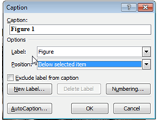

**Fig. 1.2**: How to insert automatic captions for tables and figures

To reference a table in the text, use, for example, “…shown in **Tab. 1.1**…” or “(see **Tab. 1.1**)”. The name of the table is given, for example, as follows: “**Table 1.1**: First table” (Figure and Table caption style) and it is placed above the table. Inside the table, use the Text in Table style (font size 11 pt); however, you have to set the alignment and font style as follows:

* bold for the table header,
* left-aligned for the first column, including the header,
* centred text for the header of other columns,
* for other columns in the table, use alignment as necessary; in case of figures, ideally by decimal point.

Ideally, a table should have the same width as the text.

Use an appropriate number of borders in the tables so that the tables are well organized, but not fragmented. Tables should not include any vertical lines nor horizontal lines, with the exception of separating the header (and the lines around the table). The appropriate width of the outer borders is 1½ pt and ½ pt for the inner lines. If absolutely necessary, a table can be placed on two pages. Examples:

**Table 1.5**: Concentration of analytes

|  |  |
| --- | --- |
| **Analyte** | $$q_{\text{sv}}$$ |
| hexane | 0.015 |
| benzene | 2.5 |
| methyl ethyl ketone | 11 |
| acetaldehyde | 99 |
| ethanol | 1150 |
| methanol | 1670 |

**Table 1.6**: Total weight ($∑ρ$) and total molar concentrations ($∑c$) of three model mixtures

|  |  |  |  |  |  |  |  |  |  |  |
| --- | --- | --- | --- | --- | --- | --- | --- | --- | --- | --- |
| **Compound** | $$M_{\text{r}}$$ |  | $$c_{\text{I}}$$ | |  | $$c_{\text{II}}$$ | |  | $$c_{\text{III}}$$ | |
|  |  |  | **mg l–1** | **µmol l–1** |  | **mg l–1** | **µmol l–1** |  | **mg l–1** | **µmol l–1** |
| chlorophenol | 128.6 |  | 1 | 7.77 |  | 1 | 7.77 |  | 10 | 77.7 |
| dichlorophenol | 163.0 |  | 1 | 6.13 |  | 10 | 61.3 |  | 1 | 6.13 |
| pentachlorophenol | 266.3 |  | 10 | 37.5 |  | 1 | 3.75 |  | 1 | 3.75 |
| $∑ρ$ (mg l–1) | – |  | 12 | – |  | 12 | – |  | 12 | – |
| $∑c$ (mmol l–1) | – |  | – | 51.4 |  | – | 72.82 |  | – | 87.58 |

If there is more text under the table, set the line spacing above the paragraph between 6 and 12 pt to create some space between the last line in the table and the text below the table.

In case the table is too wide, it should have landscape orientations, see **Tab. 1.7**. If a table continues on the next page, use the header again and at the top of the table use: “Table x – continued”.

**Table 1.7**: List of compounds used in the study

|  |  |  |  |  |  |  |
| --- | --- | --- | --- | --- | --- | --- |
| **Name of compound** | **Structure (SMILES notation)** | **Reaxys Registry Number** | **CAS Registry Number** | **Sum formula** | **Molar weight / $\text{g}\text{⋅}\text{mo}{\text{l}}^{\text{-1}}$** | **InChI Key** |
| hexane | CCCCCC | 1730733 | 110-54-3 | C6H14 | 86.1772 | VLKZOEOYAKHREP-UHFFFAOYSA-N |
| propane | CCC | 1730718 | 74-98-6 | C3H8 | 44.0965 | ATUOYWHBWRKTHZ-UHFFFAOYSA-N |
| n-heptane | CCCCCCC | 1730763 | 142-82-5 | C7H16 | 100.204 | IMNFDUFMRHMDMM-UHFFFAOYSA-N |
| 1,2-dimethylethane | CCCC | 969129 | 106-97-8 | C4H10 | 58.1234 | IJDNQMDRQITEOD-UHFFFAOYSA-N |
| pentane | CCCCC | 969132 | 109-66-0 | C5H12 | 72.1503 | OFBQJSOFQDEBGM-UHFFFAOYSA-N |
| octane | CCCCCCCC | 1696875 | 111-65-9 | C8H18 | 114.231 | TVMXDCGIABBOFY-UHFFFAOYSA-N |
| 2-methyl propane | CC(C)C | 1730720 | 75-28-5 | C4H10 | 58.1234 | NNPPMTNAJDCUHE-UHFFFAOYSA-N |
| decane | CCCCCCCCCC | 1696981 | 124-18-5 | C10H22 | 142.285 | DIOQZVSQGTUSAI-UHFFFAOYSA-N |
| 2-methyl-butane | CCC(C)C | 1730723 | 78-78-4 | C5H12 | 72.1503 | QWTDNUCVQCZILF-UHFFFAOYSA-N |
| [3.3.1]nonane | CCCCCCCCC | 1696917 | 111-84-2 | C9H20 | 128.258 | BKIMMITUMNQMOS-UHFFFAOYSA-N |
| 2,2,4-trimethylpentane | CC(C)CC(C)(C)C | 1696876 | 540-84-1 | C8H18 | 114.231 | NHTMVDHEPJAVLT-UHFFFAOYSA-N |
| neopentane2,2-dimethylpropane | CC(C)(C)C | 1730722 | 463-82-1 | C5H12 | 72.1503 | CRSOQBOWXPBRES-UHFFFAOYSA-N |
| 2,3-dimethyl-butane | CC(C)C(C)C | 1730737 | 79-29-8 | C6H14 | 86.1772 | ZFFMLCVRJBZUDZ-UHFFFAOYSA-N |
| 2,4-dimethylbutane | CCCC(C)C | 1730735 | 107-83-5 | C6H14 | 86.,1772 | AFABGHUZZDYHJO-UHFFFAOYSA-N |
| 3-methyl-pentane | CCC(C)CC | 1730734 | 96-14-0 | C6H14 | 86.1772 | PFEOZHBOMNWTJB-UHFFFAOYSA-N |
| ethyl trimethyl methane | CCC(C)(C)C | 1730736 | 75-83-2 | C6H14 | 86.1772 | HNRMPXKDFBEGFZ-UHFFFAOYSA-N |

*Table 1.7 – continued*

|  |  |  |  |  |  |  |
| --- | --- | --- | --- | --- | --- | --- |
| **Name of compound** | **Structure (SMILES notation)** | **Reaxys Registry Number** | **CAS Registry Number** | **Sum formula** | **Molar weight / $\text{g}\text{⋅}\text{mo}{\text{l}}^{\text{-1}}$** | **InChI Key** |
| 2,4-dimethyl pentane | CC(C)CC(C)C | 1696855 | 108-08-7 | C7H16 | 100.204 | BZHMBWZPUJHVEE-UHFFFAOYSA-N |
| 1,2,4-trimethylbutane | [H]C(C)(CC)CCC | 1718740 | 589-34-4 | C7H16 | 100.204 | VLJXXKKOSFGPHI-UHFFFAOYSA-N |
| dimethyl-pentane | CCCCC(C)C | 1696856 | 591-76-4 | C7H16 | 100.204 | GXDHCNNESPLIKD-UHFFFAOYSA-N |
| 2,2,3-trimethyl-butane | CC(C)C(C)(C)C | 1730756 | 464-06-2 | C7H16 | 100.204 | ZISSAWUMDACLOM-UHFFFAOYSA-N |
| 2-methyl-heptane | CCCCCC(C)C | 1696862 | 592-27-8 | C8H18 | 114.231 | JVSWJIKNEAIKJW-UHFFFAOYSA-N |
| 2,5-Dimethylhexane | CC(C)CCC(C)C | 1696877 | 592-13-2 | C8H18 | 114.231 | UWNADWZGEHDQAB-UHFFFAOYSA-N |
| 2,3-dimethyl-pentane | CCC(C)C(C)C | 1718734 | 565-59-3 | C7H16 | 100.204 | WGECXQBGLLYSFP-UHFFFAOYSA-N |
| 2,2,3,3-tetra-methylbutane | CC(C)(C)C(C)(C)C | 1696864 | 594-82-1 | C8H18 | 114.231 | OMMLUKLXGSRPHK-UHFFFAOYSA-N |
| 2,2,4-trimethyl-butane | CCCC(C)(C)C | 1730757 | 590-35-2 | C7H16 | 100.204 | CXOWYJMDMMMMJO-UHFFFAOYSA-N |

### Figures and graphs

Similar rules apply to figures, with the following differences. To reference a figure in the text, use, for example, “… shown in **Fig. 1.1**…” or “(see **Fig. 1.1**). The name of the figure is given, for example, as follows: “**Fig. 1.1**: First figure” and is placed below the figure (Figure and Table caption style).

inserted empty line

PLACE FIGURE HERE, CENTRE-ALLIGNED

**Fig. 1.1**: Example of a figure

It is MOST IMPORTANT to use figures with high enough resolution suitable for print.

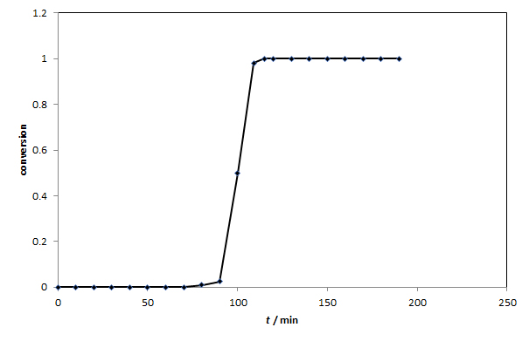

**Fig. 1.3**: Conversion of methane in a semi-pilot reactor

### Equations and formulas

#### Mathematical symbols and equations

Unlike in Czech, we use a decimal point in decimal numbers in English (e.g.: 3.14). We do not use spaces between thousands, etc.; however, we can use a comma separator for more clarity instead (e.g. 41,568).

For the minus symbol representing subtraction, we use the appropriate character, i.e. $-$, which has the same length as the plus sign, $+$. For multiplication, we use the × symbol (note that this is not lowercase “x”!), the dot operator $⋅$ (note that just like the other mathematical symbols, the dot operator is separated by spaces before and after and it is not identical with the full stop symbol), or the multiplication symbol is omitted altogether (e.g., *ab*); however, with numbers we use $a ×2$ or $2 ×2$. We never use the asterisk symbol, *. Mathematical symbols are always separated by spaces before and after, e.g., $2a+b=c$ or $45⋅3.25≠V$.

Equations must be inserted as an object created in a mathematics editor (the Equation Editor in Word) and are numbered using numbers in brackets placed to the right of the equation. The rules for numbering of figures and tables apply also to numbering of equations, see Para. 1.2.2. To reference an equation in the text, use, for example, “…eq. (1.1) applies to…” or “see eq. (1.1)”. For equations, use the Equation style: the line with the equation is left-aligned and is adjusted using two tabulators (centre-aligned for the equation, right-aligned for the number of the equation).

$α+β\left(\frac{∑(a+b)}{∑(x^{2}+y^{2})}\right)=\sqrt{δ}+ε$ (1.1)

#### Chemical formulas and equations

We always use “classical” spelling of chemical elements and compounds. A valid chemical nomenclature must be used.

Element symbols and compound formulas are always written upright (also in an italic text!).

The formula of one compound is always written as one word (no spaces, e.g., CuSO4.10H2O,  
1,2-dichlorethane). In chemical equations, we use no spaces between the coefficient and the formula:

${\text{H}}_{\text{2}}\text{ → 2 }{\text{H}}^{\text{+}}\text{+}{\text{e}}^{-}$ (1.2)

For more on the notation of equations, quantities, symbols and units, see:

* Julakova, E., Rovnice, jednotky a veličiny - jak s nimi? *Chem Listy* **2005,** *99* (4), 250-257. <http://www.chemicke-listy.cz/docs/full/2005_04_250-257.pdf>
* International Union of Pure and Applied Chemistry; Cohen, R., *Quantities, units and symbols in physical chemistry*. 3nd ed.; Royal Soc. of Chemistry: Cambridge, 2007, 978-0-85404-433-7. <http://pubs.rsc.org/en/Content/eBook/978-0-85404-433-7>
* McNaught, A. D.; Wilkinson, A.; Jenkins, A.; Nic, M.; Jirat, J.; Kosata, B., IUPAC Compendium of Chemical Terminology - the Gold Book. <http://goldbook.iupac.org>

# State of Art

This section contains the literary search directly linked to the given topic and its critical assessment.

# EXPERIMENTAL PART

This part contains a full list and a description of the used materials and chemicals, analytical, synthetic, isolation and separation methods, including instrumentation, as well as technological procedures, statistical methods, software, AI tools etc. It is usually divided into several subchapters, such as Materials and Methods, General Procedures, Prepared Compounds. It is not recommended to include every experiment in decimal classification. Specifically in this section, use moderation in how you number the subchapters – less is more. The student must include the source of the results included in the bachelor thesis. If a previously described substance is prepared using a method described in the literature, no detailed description of the experiment is included, instead a citation is used and the obtained yield, and measured and published selected physical constants for the substance (melting point, boiling point, rotation, etc.) are compared. The method is included only when the original prescription has been modified in any way. A full name of the compound together with the number of the compound, if a number has been assigned, are always given. The weight of the substances and agents is always given in grams and moles, or possibly in millimoles. Spectral data (NMR, MS) can be summarized for more substances in a table, or it can be given for individual compounds in this part of the text. If this data is used in the discussion, it will be put in the Results and Discussion section. If it simply characterizes the prepared substance, it will be put in the Experimental Part chapter.

If you are using AI-generated content in your thesis, it is advisable to mention in this part the tools that you have used, and the extent and purpose of use. Please note that all textual and nontextual materials created by AI tools can be used only as a basis for further work, not as results of your work. AI-generated results must always be verified! The author of the work is **fully and unconditionally responsible** for their use.

# RESULTS AND DISCUSSION

This section presents the results as text, tables, graphs, figures and schemes together with a written commentary. The measured data is always given just once, i.e., if it is put in a graph, it is not shown in a table, etc. Spectra and chromatograms are not included as figures in the text, nor in appendices, unless they are important for the discussion on determining the configuration, etc. Own results must be discussed critically in light of previously published findings in the field; they must be confronted with data in the literature. The thesis results and the discussion of the results can be included in separate chapters based on recommendations of the supervisor.

# CONCLUSIONS

Conclusions sum up the results, give an overview of the whole thesis, highlight the new findings, provide recommendations ensuing from the thesis. This section **must not copy the summary** – it is not a mere repetition of the obtained results.

REFERENCES

A numbered list of used sources, which must correspond to citations actually used in the thesis. Most likely, it will be a list of references generated from a reference manager (EndNote, Mendeley, etc.). For more on how to note the references, see Para. 1.1.4.

LIST OF ABBREVIATIONS

An optional, but recommended part of the thesis. It includes an alphabetized list of used abbreviations. Quantities symbols and units defined in the SI system are not included (they are put in the List of Symbols).

A list of the most common abbreviations, acronyms (and symbols) is given Appendix 10-2, pp 169-202 (Computer and Internet abbreviations in Appendix 10-1, pp 163-168.), in chapter:

* Editorial Style. In *The ACS Style Guide*, American Chemical Society: 2006; pp 135-202. <http://dx.doi.org/10.1021/bk-2006-STYG.ch010>

A list of abbreviations that **never need to be explained** (in scientific writing in English) is on pp 158-159, ibid.

Use the “List of Symbols” style, separate the abbreviation and the explanation with a tabulator.

Example:

MD molecular dynamics

PET positron emission tomography

PP polypropylene

PU polyurethane

LIST OF SYMBOLS

An optional, but recommended part of the thesis. Provide a list of symbols used, ideally including the units and/or physical size. Groups of symbols are ordered alphabetically; the order of the groups is as follows:

* Latin alphabet lower case,
* Latin alphabet upper case,
* Greek symbols,
* other symbols.

Use the “List of Symbols” style.

Example:

$c$ concentration, $\text{mol }{\text{m}}^{\text{-3}}$

$c_{p}$ specific heat capacity of gas, $\text{J }{\text{K}}^{\text{-1}}\text{k}{\text{g}}^{\text{-1}}$

$k_{\text{c}}$ mass transfer coefficient, $\text{m }{\text{s}}^{\text{-1}}$

$D$ diffusion coefficient, ${\text{m}}^{\text{2}} {\text{s}}^{\text{-1}}$

$α$ heat transfer coefficient, $\text{J }{\text{m}}^{\text{-2}}\text{⋅K }{\text{s}}^{\text{-1}}$

LIST OF TABLES

An optional part of the thesis. It shall be used mainly in longer theses (dissertations/master theses). If you used the “Insert Caption” function (MS Word), you can easily insert a list of tables: References / Insert List of Figures / select Caption label “Table” / OK

Table 1.1: The basic page setup for bachelor theses, master theses and dissertations. For table and figure captions, use the “Figure and Table Caption” style. For the text in the table, use the “Text in Table” style 1

Table 1.2: Recommended length – number of pages of Bachelor thesis (BT) 2

Table 1.3: Recommended length – number of pages of Master thesis (MT) 2

Table 1.4: Most important predefined styles 4

Table 1.5: Concentration of analytes 9

Table 1.6: Total weight ($∑ρ$) and total molar concentrations ($∑c$) of three model mixtures 9

Table 1.7: List of compounds used in the study 10

LIST OF FIGURES

An optional part of the thesis. It shall be used mainly in longer theses (dissertations/master theses). If you used the “Insert Caption” function (MS Word), you can easily insert a list of figures: References / Insert List of Figures / select Caption label “Figure” / OK

Fig. 1.1: Disabling joint citations in EndNote for the ACS style 6

Fig. 1.2: How to insert automatic captions for tables and figures 8

Fig. 1.3: Conversion of methane in a semi-pilot reactor 12

APPENDICES

This section includes, for example, registration records, schemes, sample chromatograms or spectra, etc., if required by the nature of the thesis.

If the appendices section needs further dividing, use letters A, B, C, etc.

Appendices bigger than A4 (for example, large format photographs) should be consulted with the print shop.